School of Technology

**B. Tech CSE – Sem VI**

**Advanced Java Technology (BTCS603)**

LAB MANUALS

Name :- Ankit Senjaliya

Enrollment No. :- 19BT04046

**Practical No:1**

Aim: Declare a class called Library which maintains a stock of books. Define methods to

maintain the stock of books based on issue or return by students. Also, declare a

method named search Book() which should return the availability of books based on

the Bookname given.

Program:

Book

package adwancejava;

public class Book {

String bookName;

int NoOfBooks;

String Author;

public void setBookName(String bookName) {

this.bookName = bookName;

}

public String getBookname(){

return this.bookName;

}

public void setNoOFBooks(int NoOfBooks) {

this.NoOfBooks = NoOfBooks;

}

public int getNoOFBooks() {

return this.NoOfBooks;

}

public void setAuthor(String Author) {

this.Author = Author;

}

public String getAuthor() {

return this.Author;

}

}

Library

package adwancejava;

import java.util.*;

public class Library {

Library(){

Scanner scanner = new Scanner(System.in);

System.out.println("Enter The Book Name = ");

String book_name = scanner.nextLine();

System.out.println("Enter The Number Of Books = ");

int no_of_book = scanner.nextInt();

scanner.nextLine();

System.out.println("Enter The Name Of Author = ");

String author_name = scanner.nextLine();

Book book = new Book();

book.setBookName(book_name);

book.setNoOFBooks(no_of_book);

book.setAuthor(author_name);

System.out.println("\nBook Details :- ");

System.out.println("\nBook Name Is = " + book.getBookname());

System.out.println("No.Of Books Is = " + book.getNoOFBooks());

System.out.println("Author Of Book Is = " + book.getAuthor());

}

public static void main(String[] args){

new Library();

}

}

Output:

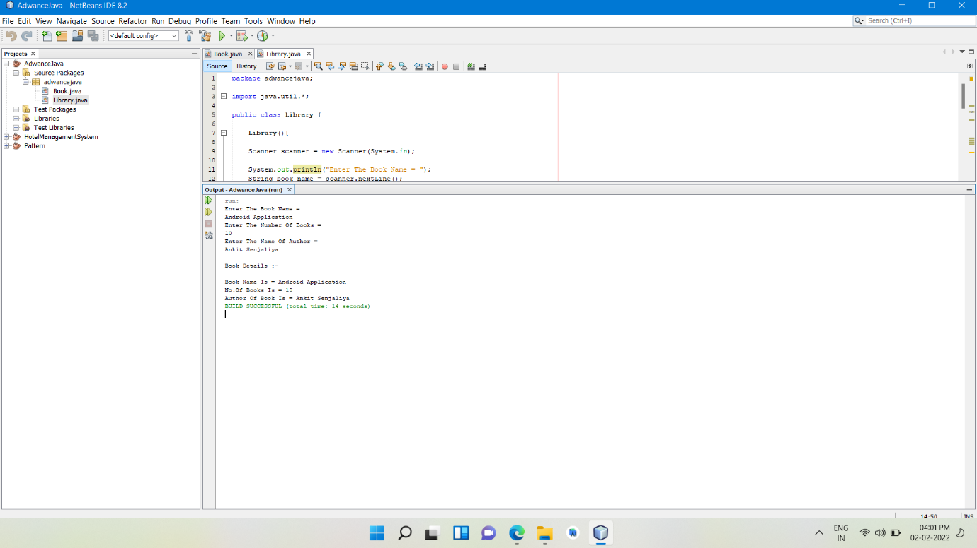

Aim: Declare a class called HR which maintains a record of each individual employee’s

performance in terms of the score. A Manager class assigns a score to each employee

on the scale of 10 and salary is incremented accordingly. Print the record of any Five

employees with their salaries before and after increments.

Program:

Employee

package adwancejava;

public class employee {

String Name;

int Emp_id;

String Degi;

int salary;

public void setName(String Name) {

this.Name = Name;

}

public String getName() {

return this.Name;

}

public void setEmp_id(int Emp_id) {

this.Emp_id = Emp_id;

}

public int getEmp_id() {

return this.Emp_id;

}

public void setDegi(String Degi) {

this.Degi = Degi;

}

public String getDegi() {

return this.Degi;

}

public void setsalary(int salary) {

this.salary = salary;

}

public int getsalary() {

return this.salary;

}

}

**Practical No:2**

Aim: Write a Program to copy the contents of one file into other.

Program:

Read File

package Lab2;

import java.io.*;

public class read_file {

read_file(){

try{

FileReader fileReader = new FileReader("C:\\Users\\Admin\\OneDrive\\Documents\\AVS\\AnkitSenjaliya.txt");

int i;

while((i = fileReader.read()) != -1){

char ch = (char) i;

System.out.print(ch);

}

}catch(FileNotFoundException ex){

System.out.println("File Does Not Exists");

}catch(Exception e){

System.out.println(e);

}

}

public static void main(String[] args){

new read_file();

}

}

Output:

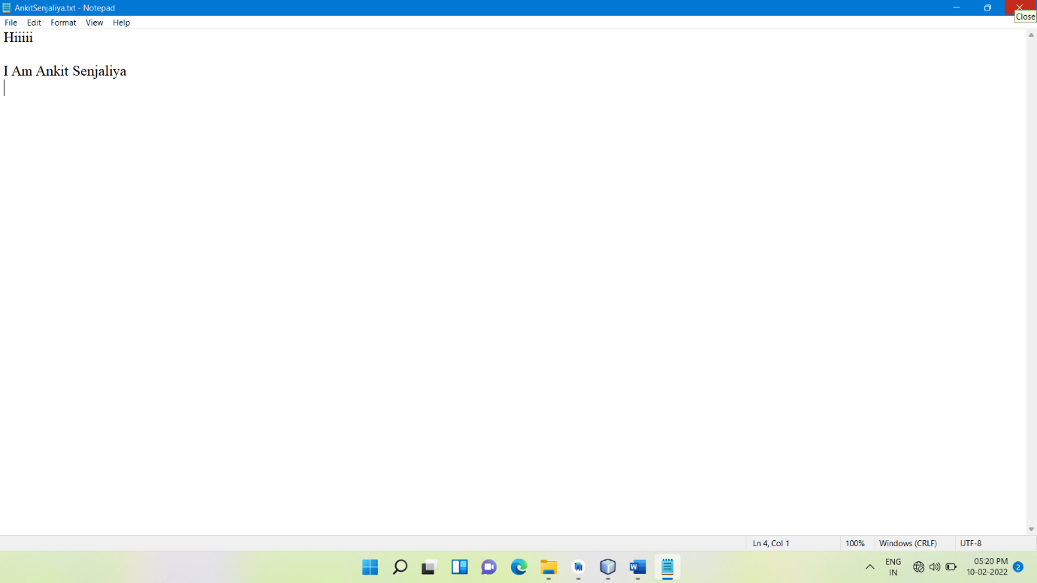

Aim: Rewrite the program of File Copy using InputStreamReader and BufferedReader

Program:

Copy File

package Lab2;

import java.io.*;

public class copy_file {

copy_file(){

try{

File infile = new File("C:\\Users\\Admin\\OneDrive\\Documents\\AVS\\AnkitSenjaliya.txt");

File ofile = new File("C:\\Users\\Admin\\OneDrive\\Documents\\AVS\\Ankit.txt");

FileInputStream instream = new FileInputStream(infile);

FileOutputStream outstream = new FileOutputStream(ofile);

int i;

while((i = instream.read()) != -1) {

outstream.write(i);

}

}catch(Exception ex){

}

}

public static void main(String arg[]) {

new copy_file();

}

}

Output:



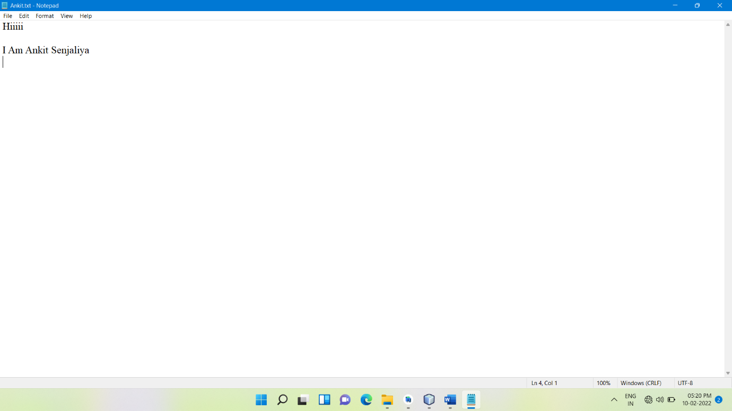

**Practical No:3**

Aim: Write a client-server application using TCP.

Program:

TCP Server

package Lab3;

import java.lang.*;

import java.io.*;

import java.net.*;

public class tcp_server {

tcp_server(){

String data = "Ankit Senjaliya";

try {

ServerSocket srvr = new ServerSocket(1234);

Socket skt = srvr.accept();

System.out.print("Server Connected SuccessFully \n");

PrintWriter out = new PrintWriter(skt.getOutputStream(), true);

System.out.print("Sending string = " + data + "\n");

out.print(data);

out.close();

skt.close();

srvr.close();

}

catch(Exception e) {

System.out.print("Server Not Connected\n");

}

}

public static void main(String args[]) {

new tcp_server();

}

}

TCP Client

package Lab3;

import java.io.BufferedReader;

import java.io.InputStreamReader;

import java.net.Socket;

public class tcp_client {

tcp_client(){

try {

Socket skt = new Socket("localhost", 1234);

BufferedReader in = new BufferedReader(new

InputStreamReader(skt.getInputStream()));

System.out.print("Received String = ");

while (!in.ready()) {}

System.out.println(in.readLine());

System.out.print("\n");

in.close();

}

catch(Exception e) {

System.out.print("Client Not Connected\n");

}

}

public static void main(String[] args){

new tcp_client();

}

}

Output:

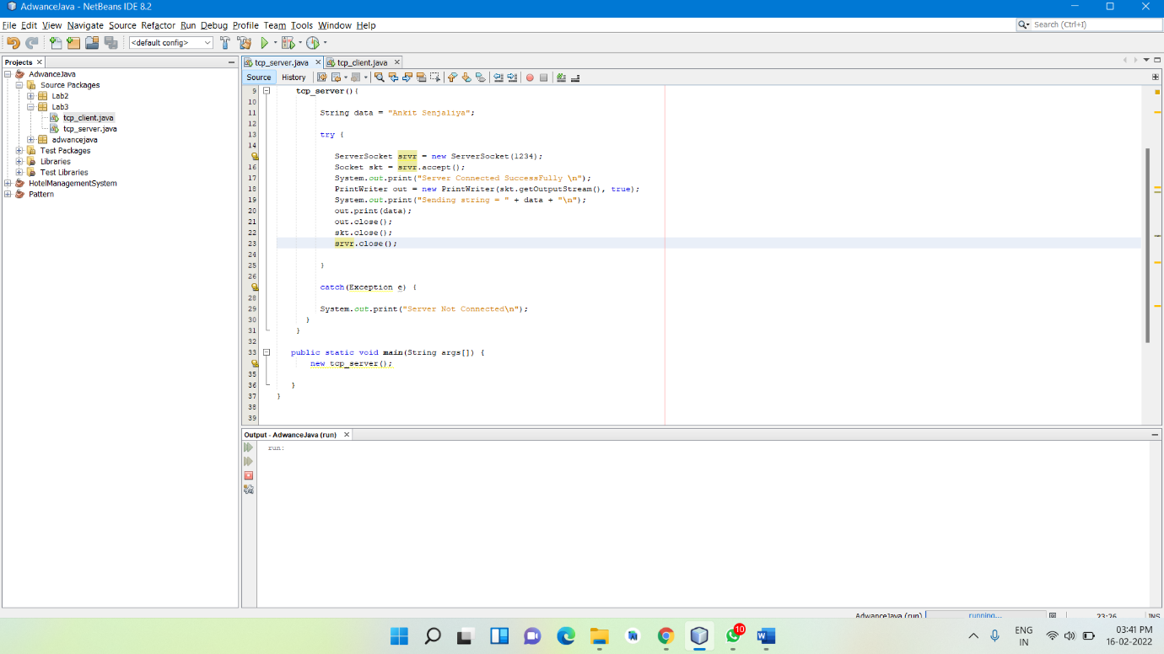

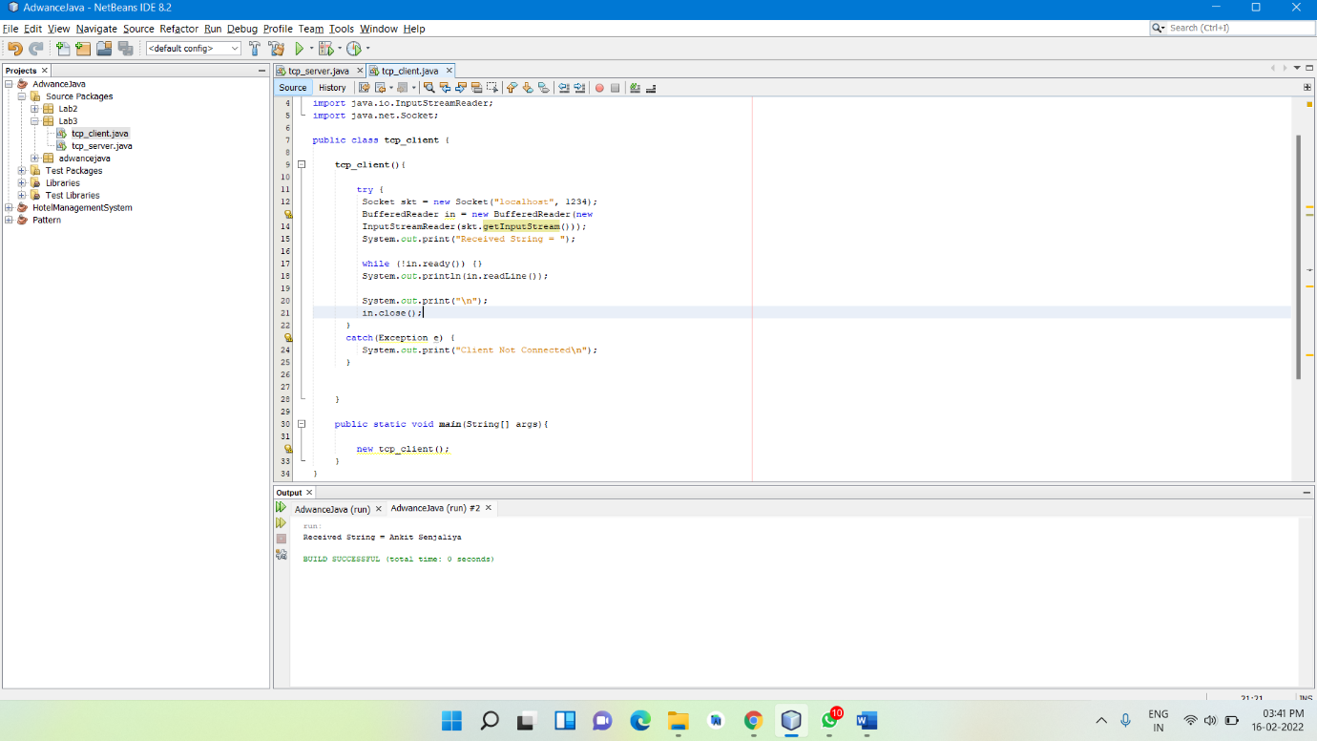

**Practical No:4**

Aim: Write a program to demonstrate a client server application using RMI.

Program:

RMI

package Lab4;

import java.rmi.*;

import java.rmi.server.*;

public class rmi{

public static void main(String args[]){

try{

Naming.rebind("Demo", new rmi_server("Hello Ankit Senjaliya"));

}catch(Exception e){

System.out.println(e);

}

}

}

RMI Interface

package Lab4;

import java.rmi.*;

import java.rmi.server.*;

interface rmi_interface extends Remote{

String getMessage(String s) throws RemoteException;

}

RMI Client

package Lab4;

import java.rmi.*;

import java.rmi.server.*;

public class rmi_client{

public static void main(String[] args) throws Exception{

rmi_interface rmi=(rmi_interface)Naming.lookup("Demo");

String msg=rmi.getMessage("Ankit Senjaliya");

System.out.println(msg);

}

}

RMI Server

package Lab4;

import java.rmi.*;

import java.rmi.server.*;

public class rmi_server extends UnicastRemoteObject implements rmi_interface{

String msg;

rmi_server(String msg)throws RemoteException{

this.msg=msg;

}

public String getMessage(String s)throws RemoteException{

return msg + s;

}

}

Output:

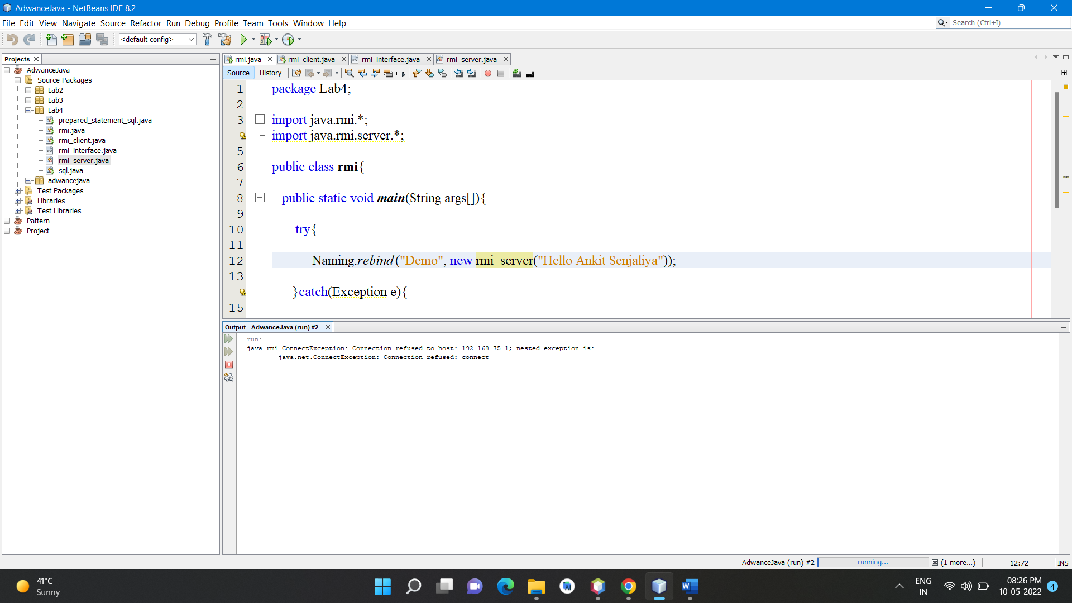

**Practical No:5**

Aim: Write a database application to print the records from Students table.

Program:

SQL

package Lab4;

import java.sql.*;

public class sql {

Connection c;

Statement s;

sql(){

try{

Class.forName("com.mysql.cj.jdbc.Driver");

c = DriverManager.getConnection("jdbc:mysql://localhost:3307/student","root","SENJALIYA@8672");

s = c.createStatement();

String str = "select * from student_details";

ResultSet rs = s.executeQuery(str);

while(rs.next()){

System.out.println(rs.getString("roll_no") + " " + rs.getString(2) + " " + rs.getString("date_of_birth"));

}

}catch(Exception e){

System.out.println(e);

}

}

public static void main(String[] args){

new sql();

}

}

Output:

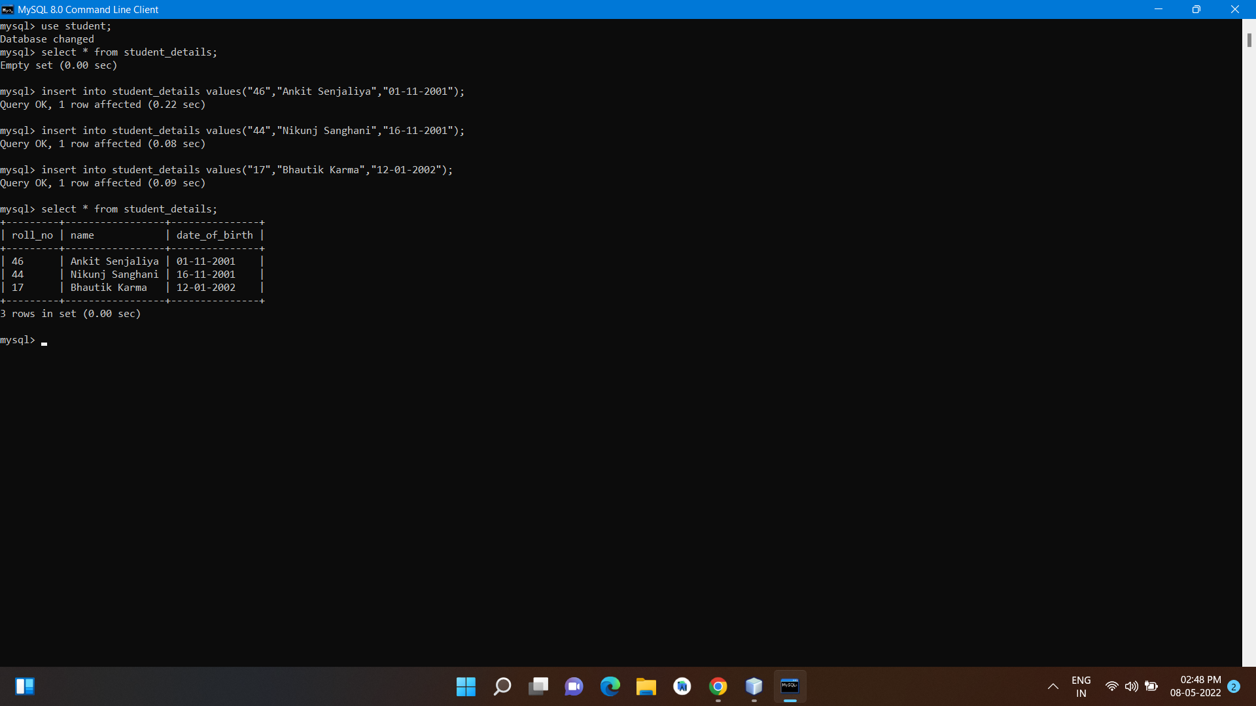

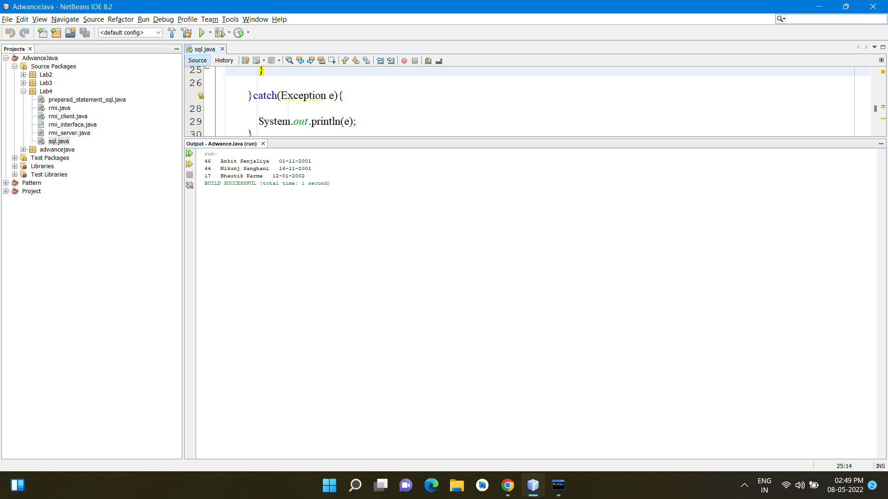

**Practical No:6**

Aim: Write a Program to perform insert, update, delete and select queries using Statement and  
Prepared Statement.

Program:

Prepared Statement

package Lab4;

import java.sql.*;

public class prepared_statement_sql {

Connection c;

Statement s;

prepared_statement_sql(){

try{

Class.forName("com.mysql.cj.jdbc.Driver");

c = DriverManager.getConnection("jdbc:mysql://localhost:3307/student","root","SENJALIYA@8672");

s = c.createStatement();

String str = "insert into student_details values(?,?,?)";

PreparedStatement ps = c.prepareStatement(str);

ps.setString(1, "58");

ps.setString(2, "Sagar Vakani");

ps.setString(3, "26-12-2001");

int i = ps.executeUpdate();

System.out.println("Add Data SuccessFully");

String str2 = "update student_details set name=?,date_of_birth=? where roll_no=?";

PreparedStatement ps2 = c.prepareStatement(str2);

ps2.setString(1, "Amish Kajavadra");

ps2.setString(2, "06-10-2001");

ps2.setString(3, "58");

int i2 = ps2.executeUpdate();

System.out.println("Data Update SuccessFully");

String str3 = "delete from student_details where roll_no=?";

PreparedStatement ps3 = c.prepareStatement(str3);

ps3.setString(1, "58");

int i3 = ps3.executeUpdate();

System.out.println("Data Deleted SuccessFully");

}catch(Exception e){

System.out.println(e);

}

}

public static void main(String[] args){

new prepared_statement_sql();

}

}

Output:

Data Insert

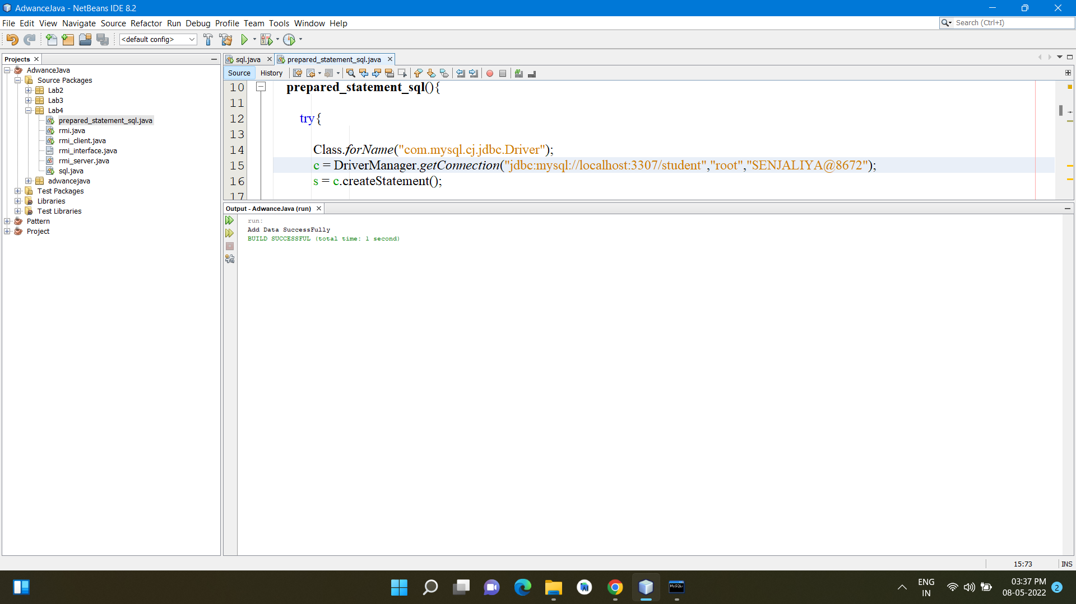

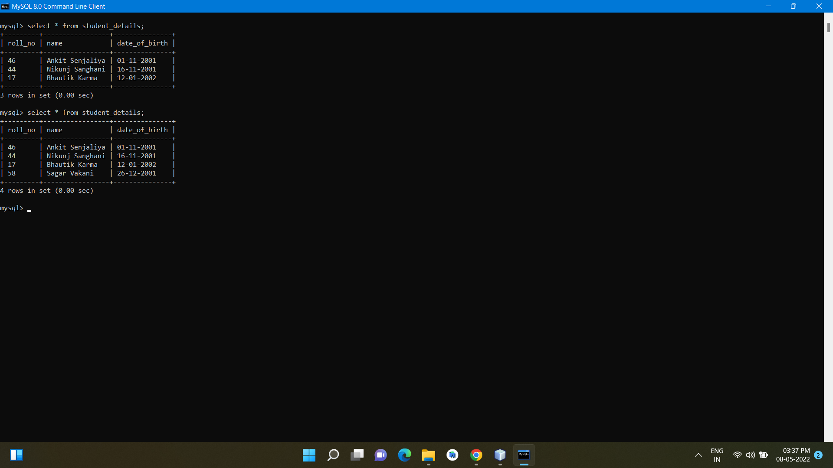

Data Update

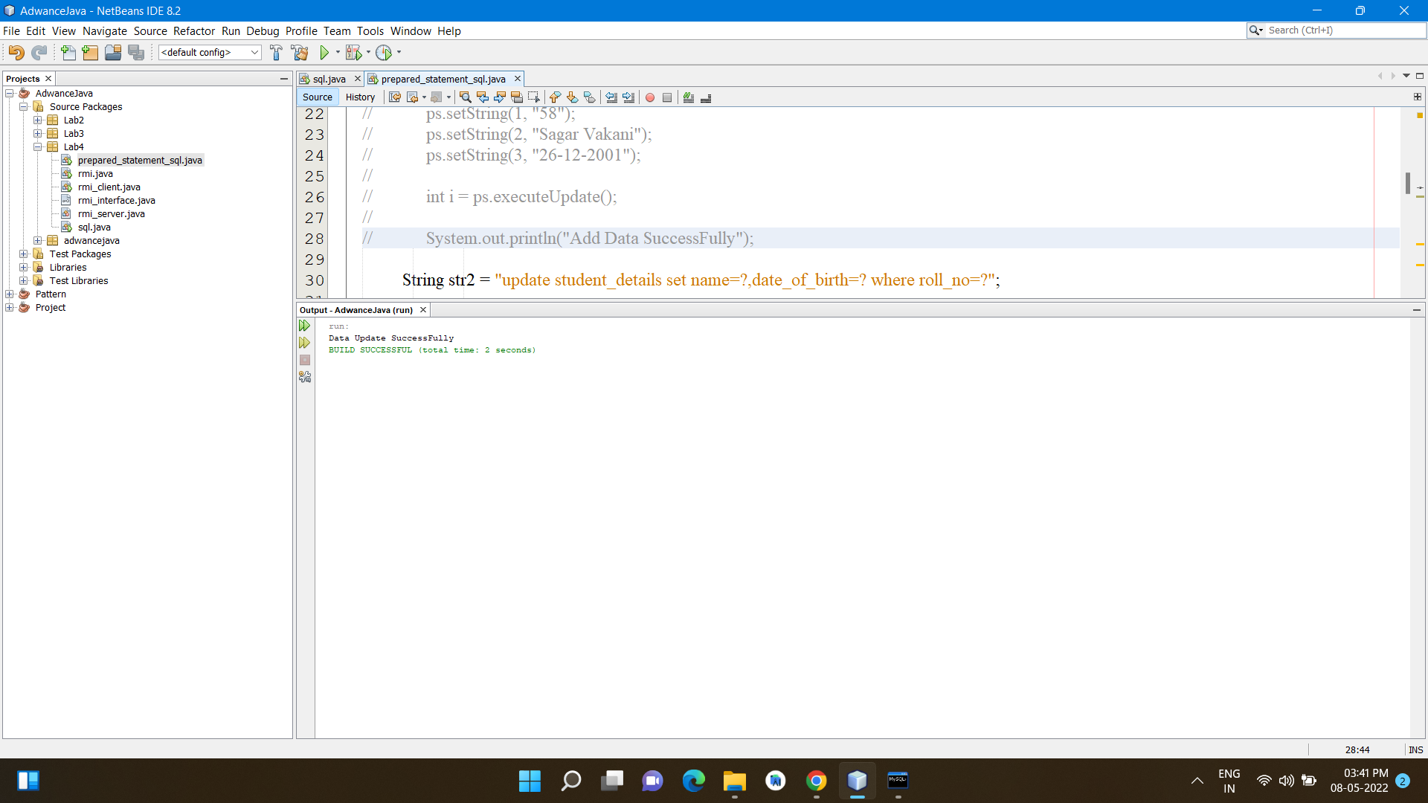

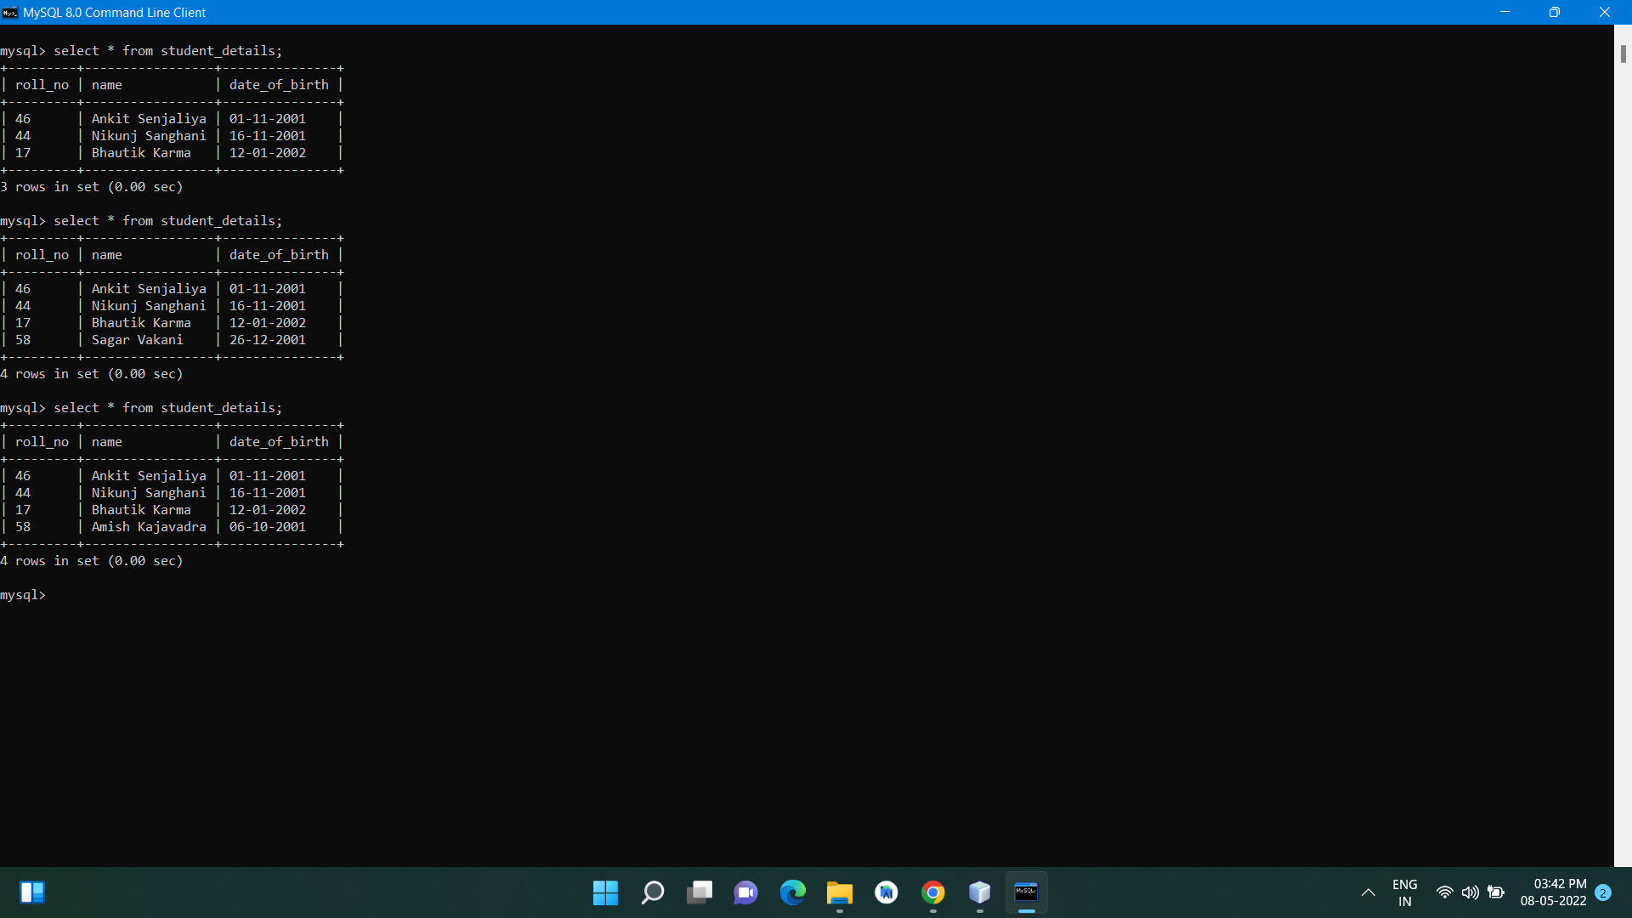

Data Delete

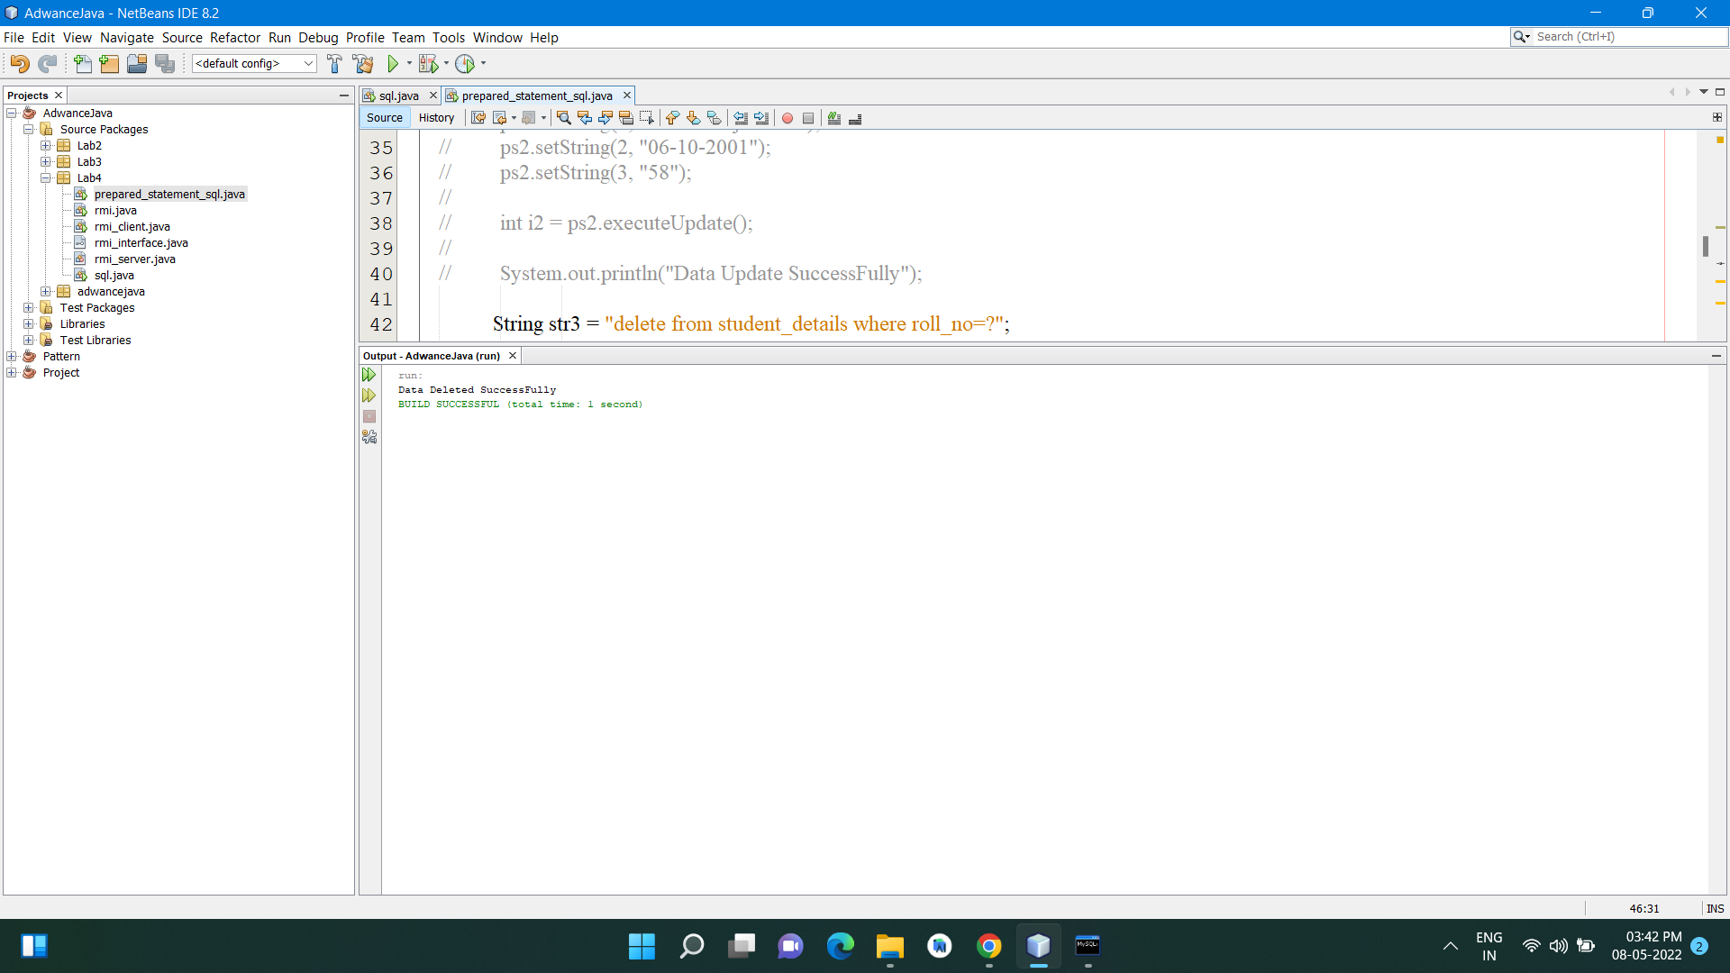

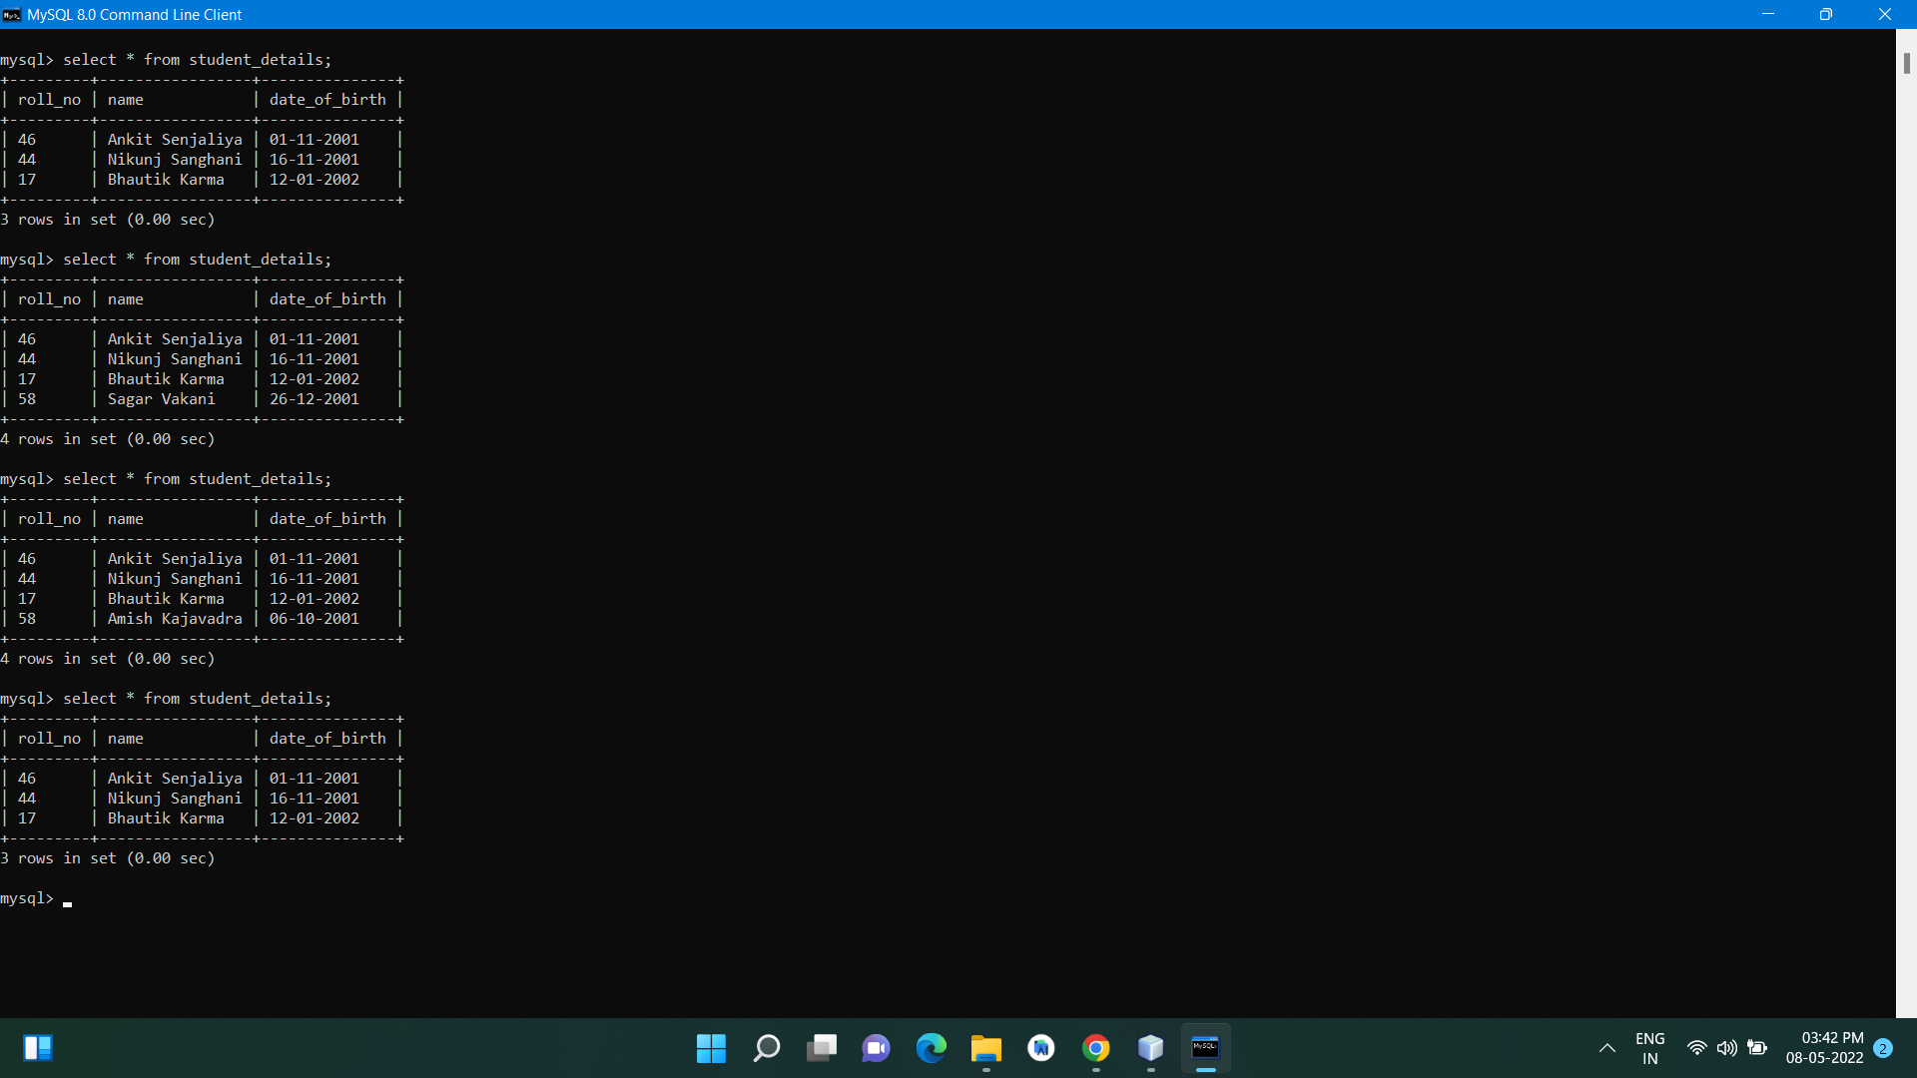

**Practical No:7**

Aim: Write a Program to execute a stored procedure using Callable Statement.

Program:

Callable Statement

package Lab4;

import java.sql.*;

public class callable_statement_sql {

Connection c;

Statement s;

callable_statement_sql(){

try{

Class.forName("com.mysql.cj.jdbc.Driver");

c = DriverManager.getConnection("jdbc:mysql://localhost:3307/student", "root", "SENJALIYA@8672");

s = c.createStatement();

String str = "insert into student_details values(?,?,?)";

CallableStatement cs = c.prepareCall(str);

cs.setString(1, "15");

cs.setString(2, "Sagar Vakani");

cs.setString(3, "26-12-2001");

cs.execute();

System.out.print("Add Data SuccessFully");

}catch(Exception e){

System.out.println(e);

}

}

public static void main(String[] args){

new callable_statement_sql();

}

}

Output:

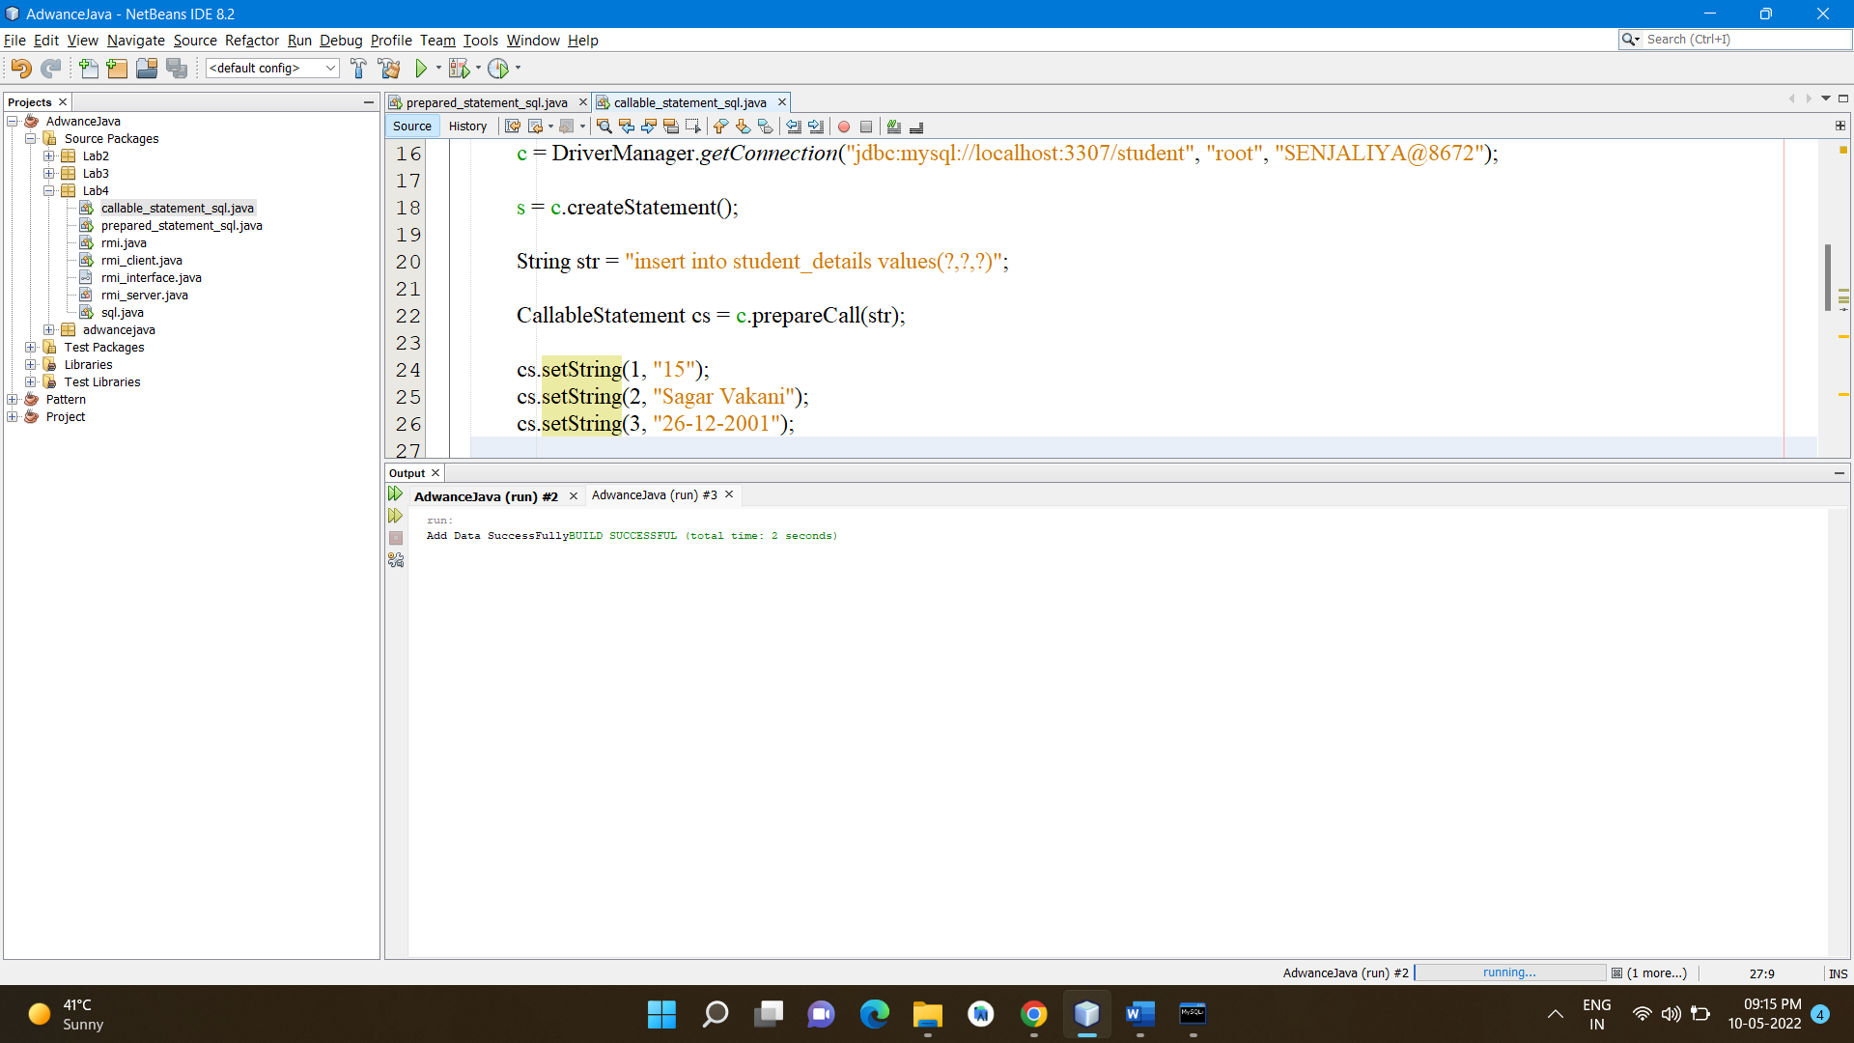

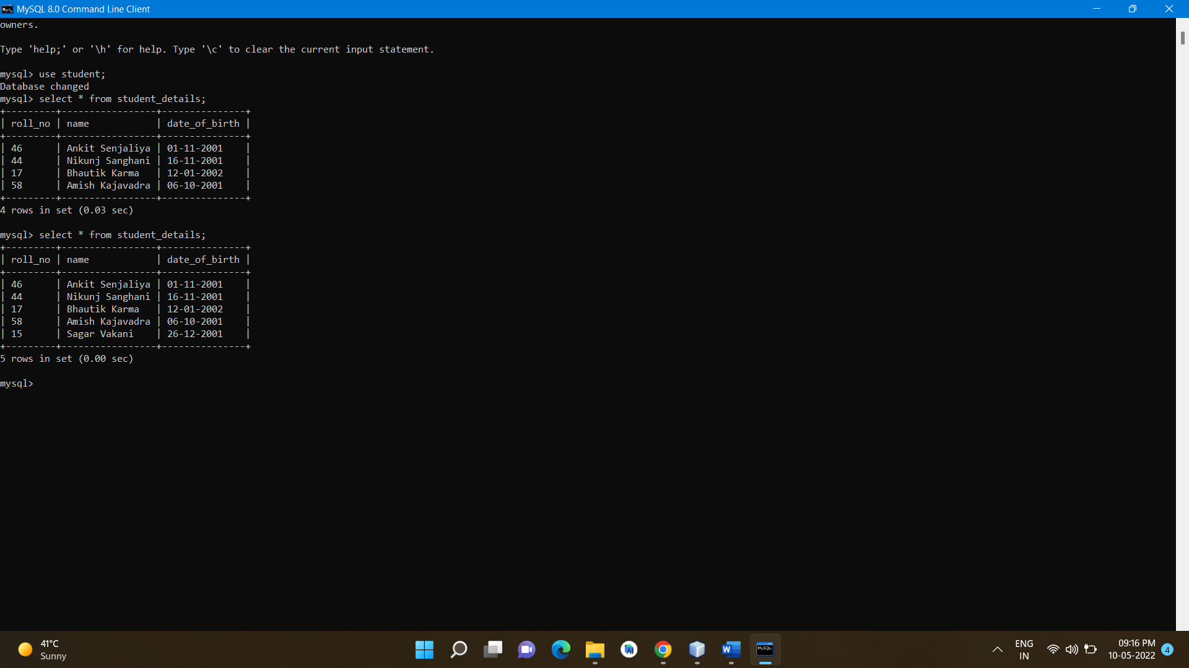

**Practical No:8**

Aim: Write a Program to make ResultSet scrollable and updatable and perform insertion and deletion using ResultSet only.

Program:

Scrollable Updateable

package Lab4;

import java.sql.*;

public class resultset_scrollable {

Connection c;

Statement s;

resultset_scrollable(){

try{

Class.forName("com.mysql.cj.jdbc.Driver");

c = DriverManager.getConnection("jdbc:mysql://localhost3307/student","root", "SENJALIYA@8672");

s = c.createStatement(ResultSet.TYPE_SCROLL_SENSITIVE,ResultSet.CONCUR_UPDATABLE);

String str = "select * from student_details";

ResultSet rs = s.executeQuery(str);

rs.next();

rs.updateString(2, "Darshan Golani");

rs.updateRow();

System.out.println("1 Row Updated...");

rs.moveToInsertRow();

rs.updateString(1,"30" );

rs.updateString(2, "Akshay Patel");

rs.updateString(3, "20-02-2002");

rs.insertRow();

System.out.println("1 Row Inserted...");

c.close();

}catch(Exception e){

System.out.println(e);

}

}

public static void main(String[] args){

new resultset_scrollable();

}

}

Output:

